Ideation Phase
Brainstorm & Idea Prioritization

Date | 25-06-2026
Team ID | 23A51A4441
Project Name | Metro Ticket Generating System in ServiceNow
Maximum Marks | 4 Marks

Brainstorming and Idea Listings:
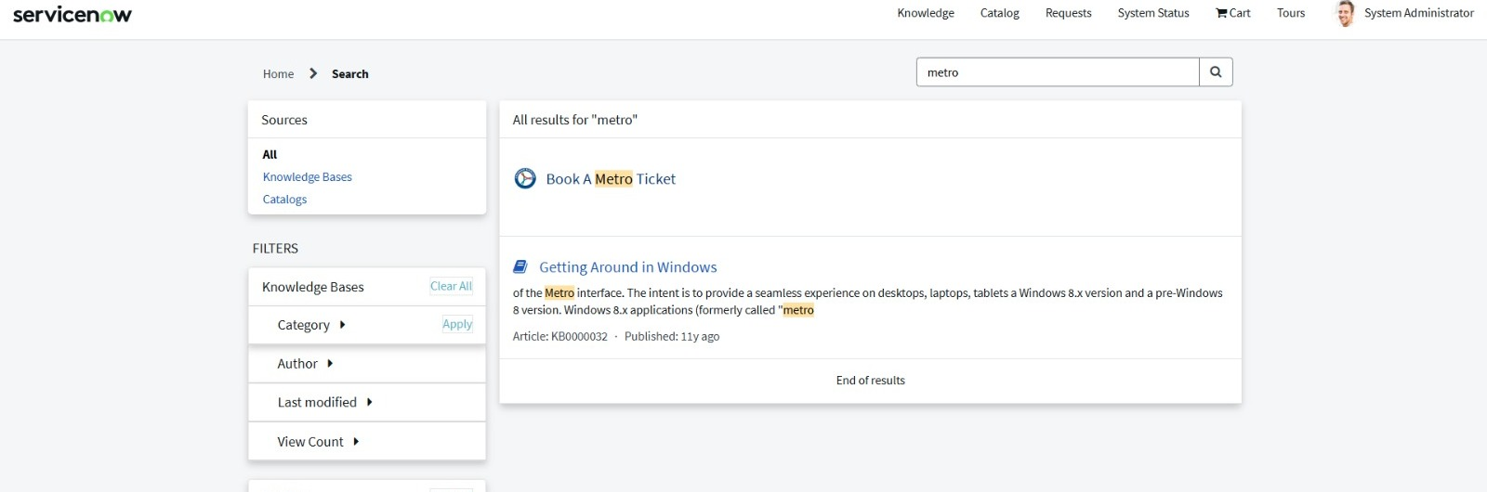
Brainstormed Features
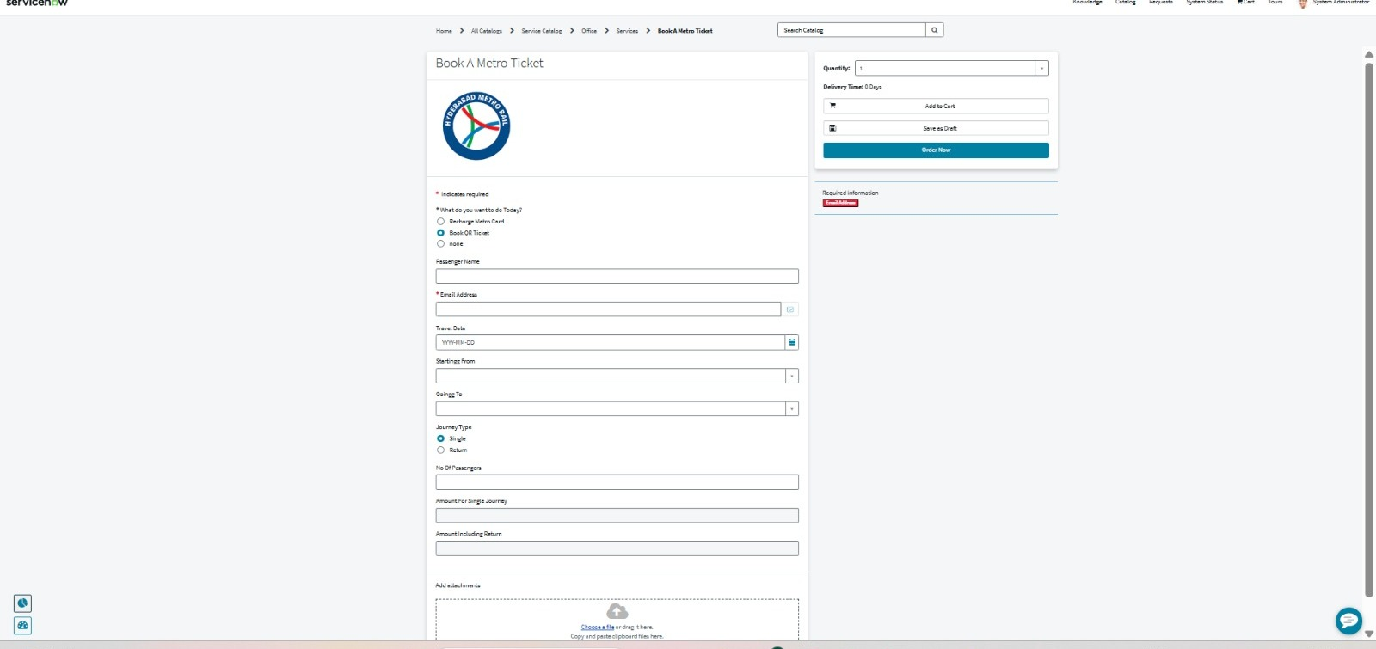
Key Objectives
- Reduce ticket booking time.
- Eliminate manual fare calculation.
- Improve passenger convenience.
- Digitize metro ticket management.

Implementation Map
